## Creating a Basic Delineator Line

All delineator lines start by default as Barrels with a size of 6 units and a spacing of 30 units. They can then be changed into the required type after placement on the plan. You can also set new default values from the Properties palette.

**To create a basic delineator line:**

* Select the Delineator from the Devices tab in the Tools Palette.
* Click once where you wish to start drawing (don’t hold).
* Click at each corner for your line.
* After you have placed the end point, right click to stop drawing.
* Right click to clear the cursor.
* 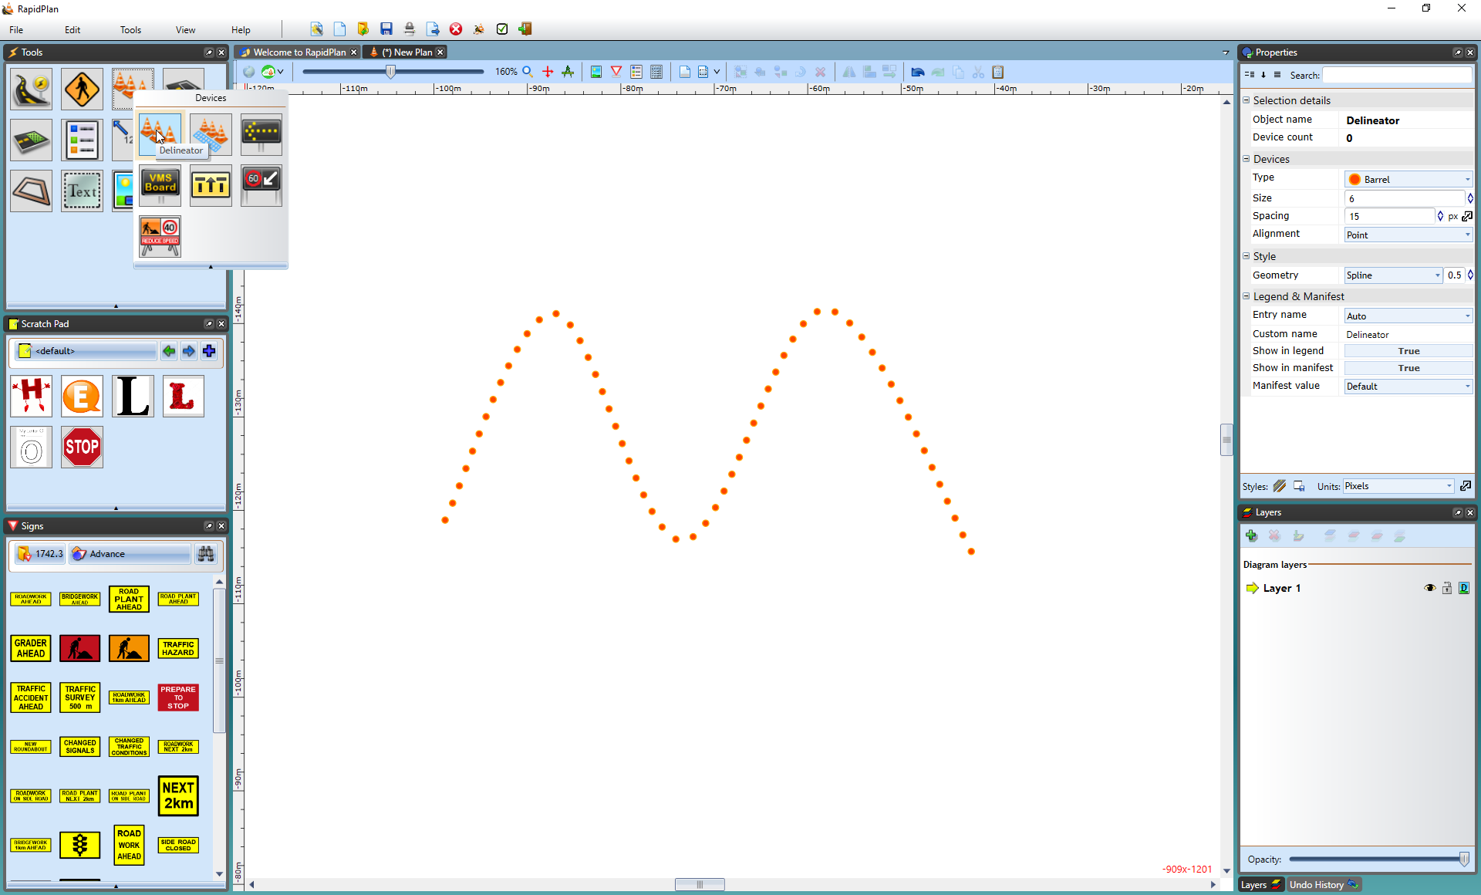
* Delineator_Line